**Question No: 01**

**(a) What are the characteristics of multimedia presentation? 2**

**Ans:**

**Characteristics of multimedia presentation:**

1. Presentation involves audio and video clip, animation can be multimedia
2. These presentation put very positive impact on audience.
3. Understand easily.
4. With the help of audio and video clips presenter present well and viewer.

**(b) What is multimedia production? What are hardware and software requirement of a multimedia production? 3.25**

**Ans:**

**Multimedia production:**

Multimedia production begins with gathering content elements that fulfills the purpose of higher layer components, followed by integration of these elements to create a meaningful presentation.

**Hardware Requirements:**

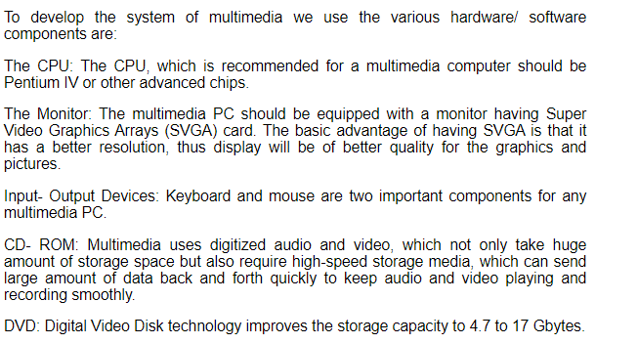

**Software requirements:**

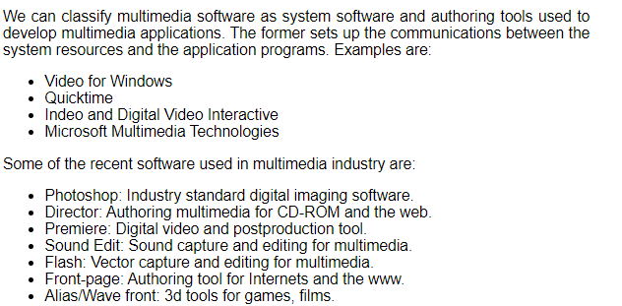

**© What is bitmapped font and true type front? What is the difference between them? 3**

**Ans:**

**Bitmapped font:** A **bitmap font**is made of raster images that define each character of a font. Bitmap fonts are non-responsive, and do not maintain their shape & character when resized to bigger/smaller sizes. These are generally meant for use in one size only.[Proggy](https://proggyfonts.net/)is a good example of a bitmap font. Bitmap fonts are rarely used nowadays.

**True type front:**

TrueType is a font format that was developed by Apple and was eventually licensed to Microsoft. They only require one file, but a separate file needs to be added for each instance of the font. Which means you'll need a different file for normal, italic, bold, bold italic, etc. TrueType typefaces are usually used in a business office since they can be a little unreliable for publishing. TrueType fonts work well with Microsoft Office. For a while TrueType fonts worked really well with PostScript fonts, meaning that the TrueType fonts would be used for screens, and PostScript for printing purposes.

**Question No: 02**

**(b) Distinguish between digital audio and MIDI music. 2.5**

**Ans:**

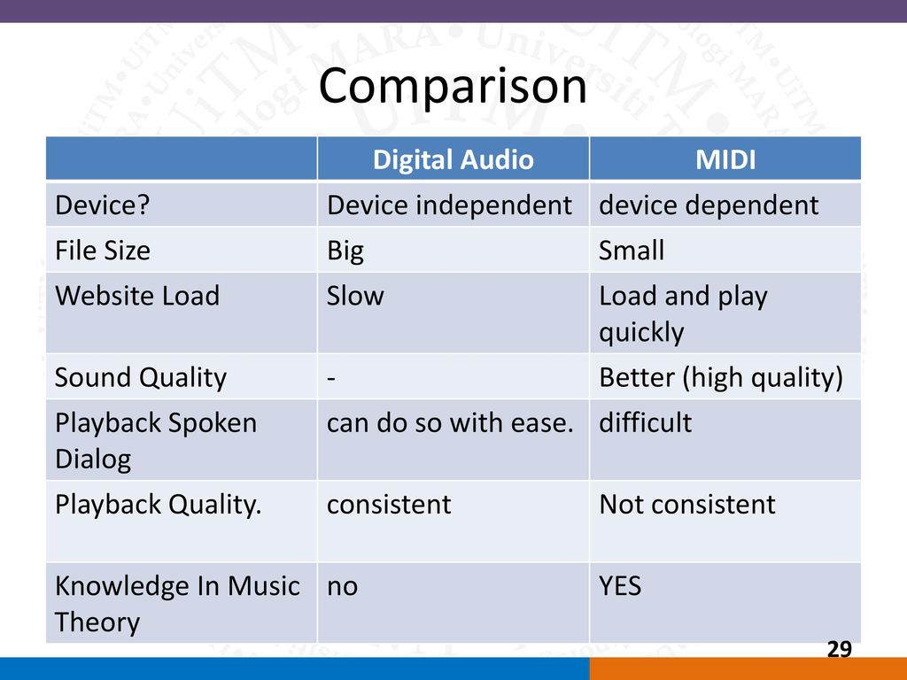

**© An audio clip has duration of 8 minutes. The highest frequency in the sound wave 20 kHz. This is to be sampling using 8 bits per sample and in stereo mode. Calculate the file size. 1.75**

**Ans:**

Here, sample rate = 20KHz

Sample size = 8 bits

Time = 8 min

File size= (sample rate* sample size* time)*2

= (20 KHz * b bits * 8 min)*2

= (20,000 Hz * 8 bits * 480 sec)*2

= 153,600,000 bits

= 18.31 MB.

**Question No: 03**

**(b) Describe the process to generate the Y and C signal from the RGB signal from a video camera. 5**

**© Consider a TV camera where the maximum intensity of a color signal is represented by 1 volt. An unsaturated magenta signal is formed by mixing 70% R, 20% G, d60% B. What is the luminance output voltage for the signal? What would this voltage for the signal? What would this value be if the magenta color is saturated? 1.75**

**Question No: 04**

**(a) Write down the Huffman coding algorithm used in lossless compression. 3**

**Ans:**

**. Initialization:** Put all symbols on a list sorted according to their frequency counts.

**2. Repeat until the list has only one symbol left:**

From the list pick two symbols with the lowest frequency counts.

Form a Huffman subtree that has these two symbols as child nodes and create a parent node.

Assign the sum of the children’s frequency counts to the parent and insert it into the list such that the order is maintained.

Delete the children from the list.

**3.** **Assign a codeword for each leaf based on the path from the root.**

**(b) What are the advantages and disadvantages of Arithmetic Coding as compared to Huffman coding? 2**

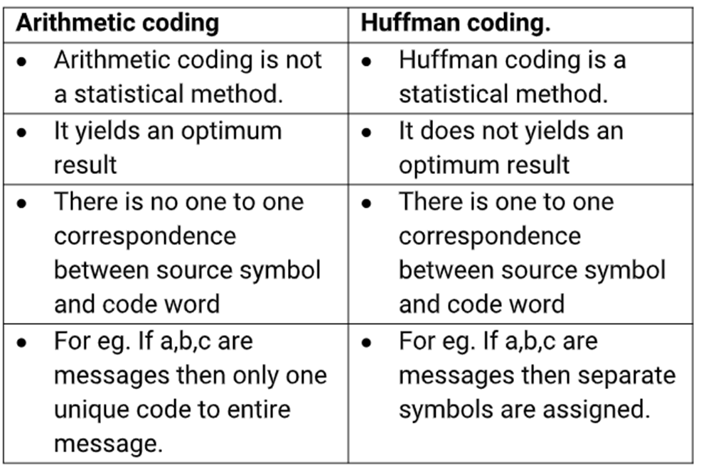

**© Write down the Huffman coding algorithm for the message “HELLO” and give its coding tree. 3.75**

**Ans:**

**1. Initialization:** Put all symbols on a list sorted according to their frequency counts.

**2. Repeat until the list has only one symbol left:**

From the list pick two symbols with the lowest frequency counts.

Form a Huffman subtree that has these two symbols as child nodes and create a parent node.

Assign the sum of the children’s frequency counts to the parent and insert it into the list such that the order is maintained.

Delete the children from the list.

**3.** **Assign a codeword for each leaf based on the path from the root.**

